Attendance at Penair School

Penair School values punctuality and good attendance very highly. Like all schools, we expect students to attend 100% of the time. 100% attendance is essential to guarantee the highest possible achievement. Our minimum expectation is that all students attend school regularly (at least 96%). All parents/carers have a legal responsibility to ensure their child attends school regularly. This is our minimum expectation as missing school damages children’s attainment levels, disrupts school routines and the learning of others.

Penair School is committed to improving overall attendance and reducing Persistent Absence (attendance of less than 90%) and we use a graduated set of attendance procedures while also working closing with the Local Authority Educational Welfare Officer. Penair School works with the Local Authority in reminding parents about their responsibility for making sure that their child attends school regularly. If a child fails to attend school regularly and punctually and the absence is recorded as unauthorised, a parent/carer is guilty of a criminal offence under Section 444 of the Education Act.

Parents/carers must make sure their children attend school regularly and if parents/carers allow their children to stay away from school without good reason then a Penalty Notice may be issued which could, in turn, result in prosecution.

It is really important that students come to school on time every day. Lateness and attendance below 100% will have a negative impact on their studies and examination results. Regular attendance and good punctuality at school enables children to make the best of the educational opportunities available to them.

Punctuality
Pupils must arrive in school by 8.30am on each school day. A pupil who arrives at school before the register has closed for morning registration at 8.35am they will be marked as late. If a pupil arrive at school after the register has closed at 9.00am a pupil will be marked as absent.

Students arriving between 8.36am – 8.50am must report to their form tutor to receive a late mark. If they arrive after 8.50am they must report to student enquiries to be given a late mark.

Should a pupil regularly arrive late to school then staff from the Pastoral team will investigate the matter further and liaise with the pupil and parent. There is a school sanction of 5 consecutive lates resulting in an after-school detention.

Attendance & Expectations

RED, AMBER, GREEN ATTENDANCE
Our aim is to find ways to help those with low attendance. We categorise levels of attendance into red, amber, and green.

Green – 96% and above.
Good attendance – in line with, or above national expected average. Ideally where all pupils should aim to be.

Amber – below 96%
Attendance is below expected level – if your child drops below 96% they are considered to be amber, a signal that attendance has dropped and needs to improve.

Red – Below 90% Persistently absent
If attendance drops below 90% there is a serious cause for concern. If attendance does not improve after intervention from school, the Education Welfare Service may become involved.

ATTENDANCE FACTS
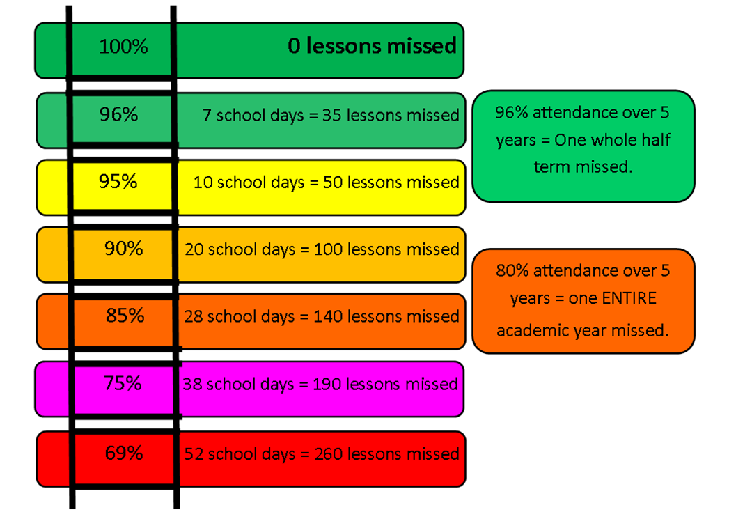

Above 97%
Less than 6 days absence in a year!
Excellent attendance! Pupils with this attendance should achieve the best grades they can.
95%
Less than 10 days absence in a year!
Pupils with this attendance are more likely to hit their grades!
90%
20 days absence over the year!
Pupils with this attendance are missing approximately a month (20days) of school per year and may fall behind in maths, literacy and other subjects; it will be difficult for them to achieve their grades!
Illness still counts towards poor attendance and parents/carers will be invited to meet with staff with their child as meetings will be called to investigate how attendance can be improved.
TO SEND OR NOT TO SEND?
Your child may wake up in the morning saying that they feel unwell. Always send your child to school unless they are being sick. If they are a little ‘under the weather’ for example with a runny nose, headache, stomach ache then please send them in, as long as your contact information is up to date, then

Absence procedures

If a student is absent, parents or carers must notify the school on the first day of an unplanned absence by 8.30am or as soon as practically possible on 01872 245169 and give the reason for the absence (see also section 7 in the Attendance policy). This will need to be repeated daily if your child is unwell for more than one day. Parents/carers should ring the school and leave a message on the school answerphone to report your child’s absence or email the relevant form tutor with reasons for the unplanned absence. The telephone system allows callers to leave a message at any time.

We will contact you by text through the automated system if your child is absent and you have not contacted us. It is essential that you respond to this message if you have not already informed us of absence.

Please note if your child has been absent for more than three days you will be asked for evidence that your child is unfit for school. It is at the school’s discretion what constitutes evidence. We really do appreciate your cooperation with this.

Medical Appointments

Where possible, we would ask that all routine medical and dental appointments should be made outside school hours. Medical and dental appointments are only authorised if medical evidence has been provided, for example: appointment cards. If medical evidence has not been provided, the appointment will be unauthorised.

On their return to school a student should bring a letter from their parent/carer to explain the absence. Medical evidence, such as a doctor’s note, prescription, appointment card or other appropriate form of evidence will be required for absences longer than 3 days. Only a hospital appointment or a visit to the orthodontist will be authorised (evidence will be required).

Leave of absence during term time

Holidays during term time are NOT allowed. The school is closed for 13 weeks each year and holidays must only be taken during this time. There are approximately 175 non-school days in a year, thus leaving plenty of time for holidays, appointments and duvet days. Any absence during term time will be rigorously followed up by the staff.

Taking a leave of absence during term time will only be authorised under exceptional circumstances in accordance with the Education (Pupil Registration) (England) Amendment) Regulations 2013. Furthermore, this is at the discretion of the headteacher. Please provide a covering letter explaining why you would like your child to have a leave of absence during term time and attach it to the Leave of absence application form for the attention of the Headteacher.

If you are experiencing difficulties in getting your child into school or there are any issues which may impact on their attendance, please contact your child's form tutor in the first instance.

Thank you for working in partnership with us to achieve the highest possible levels of attendance and punctuality at school for your child.

Please read the documents below for further information.
- Attendance Policy (Students)
- Attendance ladder
- Leave of Absence pro forma

